Facts about the Czech Republic
Location: Central Europe
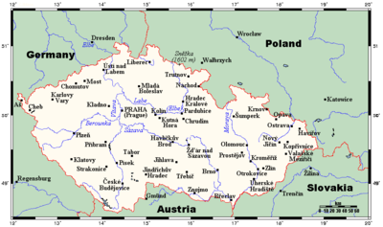
Map of the Czech Republic
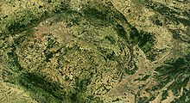
Satellite image of the Czech Republic
Terrain: Bohemia in the west consists of rolling plains, hills, and plateaus surrounded by low mountains; Moravia in the east consists of very hilly country
Elevation extremes:
- lowest point: Elbe River - 115 m (377 ft)
- highest point: Sněžka - 1,602 m (5,256 ft)
Natural resources: hard coal, soft coal, kaolin, clay, graphite, timber, uranium
Natural hazards: flooding
Geography - note: landlocked; strategically located astride some of oldest and most significant land routes in Europe; Moravian Gate is a traditional military corridor between the North European Plain and the Danube in central Europe

Climate
The Czech Republic is a landlocked country located in moderate geographical latitudes in the Northern Hemisphere. The climate of the Czech Republic is mild but variable locally and throughout the year.
The climate differs markedly among the various regions of the Czech Republic, depending on the height above sea level. Generally speaking, the higher you are, average temperatures may drop more and rainfall is more likely. Many other factors also play a role in this – the border mountain ranges, for example, significantly influence ground-level air flow and rainfall.
Various height levels of the sun during the year cause the changing of the seasons, differentiated from each other mainly by the development of temperatures and precipitation. Similarly to the whole moderate northern band, the beginning of the year in the Czech Republic is also characterized by a cold winter. After this comes spring followed by a warm summer and chilly autumn.
December, January and February are counted as the winter months. The coldest of these is January, when even in the lowlands the average monthly temperature falls below 0 °C (around - 10°C to - 20°C). If there is any precipitation in winter, it is usually snowfall in the mountains. In the lowlands it can alternately rain and snow. Snow coverage usually lasts for several months at higher altitudes above sea level, which attracts winter sports enthusiasts. Snow can remain for several days, even in the lowlands, although most winters it is rather “slushy.”
See photos which represent the winter in the Czech Republic
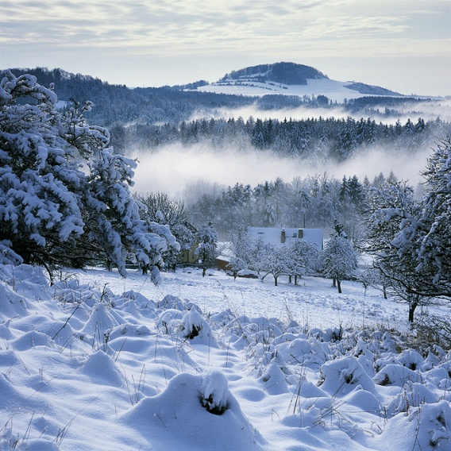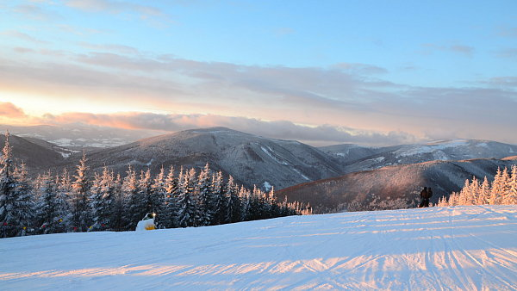
During March, April and May, there is a sharp increase in temperatures. We can get an idea of the character of individual months from the following saying: “Březen - za kamna vlezem, duben - ještě tam budem, máj - půjdeme v háj“ (“March – we get behind the stove, April – we’ll still be there, May – off we go to the garden”). Snow coverage usually disappears in the mid-spring, even in the highest mountains of the Czech Republic, so even there the swift growth of vegetation so typical for spring can occur. Czech rivers are at their fullest in spring as a result of the melting snow. There are many Czech folk traditions connected with this period.
See the pictures which represent the Spring in the Czech Republic
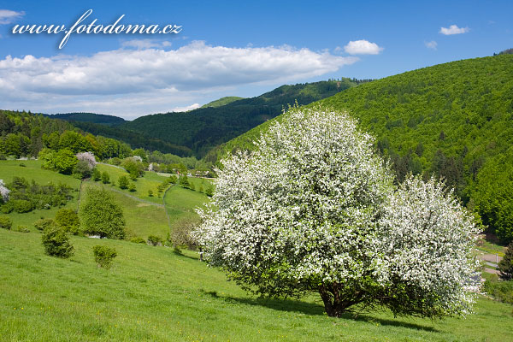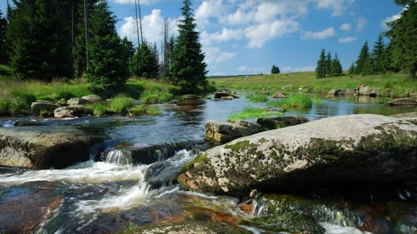
If you love heat, the best time to visit the Czech Republic is July, when the average temperature is 20 °C warmer than in January. The hottest daily temperatures can be in excess of 30 °C. Days such as these can be pleasantly spent near the water, which truly heats to a suitable temperature for swimming in the second half of summer. Another way to escape the sultry summer heat is to take a trip to the mountains, where the average daily temperatures are just over 10 °C. The hottest months are also those with the most rainfall as the hot air brings the highest level of moisture to the Czech Republic.
The first of the autumn months is September, which is still relatively hot and markedly drier than the preceding month. The period of good weather that usually comes in August is known as Indian Summer. The average daily temperatures usually fall once again below 10 °C around the start of October, which is when the leaves on the trees begin to change into a multitude of colours and fall to the ground: This is why the Czech word for November is derived from the words for falling leaves. The first light frosts can also occur at this time, announcing the nearness of the coming winter.
See the pictures that represent autumn in the Czech Republic
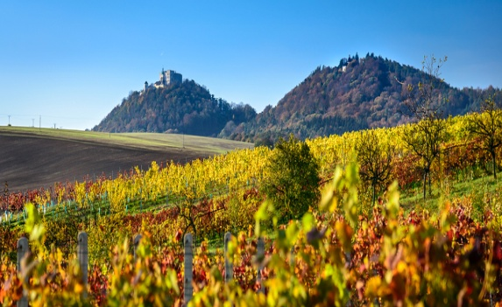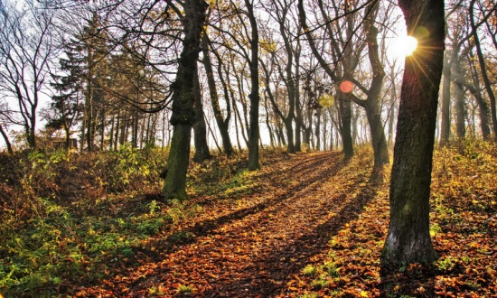

Czech language
The origins of the Czech language date to the end of the 10th century, when Czech, just like other Slavic languages, began to separate from a common protolanguage – ancient Slavonic. The first written evidence of its existence comes from this period (e.g. the Czech proper nouns Myslata, Boleslav, and Melník on Bohemian denarius from the turn of the 10th and 11th centuries). Evidence of its existence did not begin to mount until the second half of the 12th century. Thus it is only possible to consider Czech as a historically documented language from this time.

Everyone who speaks Czech can understand each other without difficulty. At the same time, as regards the state of the Czech language, there is a relatively large characteristic difference between traditional standard written Czech and the language that is commonly spoken.
The non-standard speech of the population is differentiated on a regional basis. In Bohemia, an interdialect (a transdialectal division) predominates, which is called common Czech. This has evolved on the basis of the main characteristics of the Central Bohemian dialectal group. In Moravia, we can observe more pronounced dialectal differences. This concerns three distinct dialectal regions: the Haná (central Moravian) region, the Moravian-Slovak region (or the east Moravian region, including Moravian Wallachia) and the Lassko (Silesian) region.

Ostrava
http://www.czechtourism.com/t/ostrava/

Discover a city which could have come straight from a Jules Verne novel!
This large city in North Moravia is one of the as-yet-undiscovered treasures of the Czech Republic. Ostrava’s main attractions include the fascinating technical monuments of European importance and recently also the famous Stodolní, symbol of fun and a street which never sleeps. The dominant feature of the city is the unique Lower Area of Vítkovice, which was included on the European cultural heritage list.

Prague has Hradčany, Brno has Špilberk and Ostrava has Vítkovice! The Lower Area of Vítkovice is a unique industrial complex dating back to the first half of the 19th century, which provides a great insight into the tradition of iron production in this area. Through gradual reconstruction, a unique world of technology was created here, which allows you to get to know the steel city really well just like in the Jules Verne novel.
The Vítkovice Iron Works used to belong to the Rothschild family of bankers. Just like Baťa architecture is typical in Zlín, we can admire the typical Rothschild houses in Vítkovice which were used to house the employees of their business.
MINES!
When visiting Ostrava, make sure not to miss out on a visit to Landek Park (near Diocesan Charita Ostrava- Opava). The largest mining museum in the Czech Republic is a world famous location, where geology, archaeology and mining are combined. Another of the exceptional technical monuments in Ostrava is the Michal Mine, which offers several tour routes, in which you can walk along the authentic path of a miner from the changing rooms, right to the seam itself.

ENTERTAINMENT!
Apart from technical monuments, you can also visit the Cathedral of the Divine Saviour or the medieval Silesian-Ostrava Castle in Ostrava. If you like getting a distant view, make sure to climb the tower of the New Town Hall, which rises up to a height of 73 metres over the city. The famous Stodolní Street has become a new phenomenon in the social life of Ostrava. Every weekend, dozens of original bars, restaurants and clubs here fill up with people from far and wide and even from abroad. So if you like having a good time, Stodolní will most certainly not disappoint you.

Where else to head for?
If you are planning to stay in the area for at least a few days, you certainly won’t be bored. Only 30 km from Ostrava is Kopřivnice, a town inherently connected with the legendary Tatra vehicles. Štramberk is also nearby, which looks like it came straight from a fairytale thanks to its tower known as “Trúba”. You can also liven up your trip with a visit to the city of Opava where you must make sure to visit the local co-cathedral.

